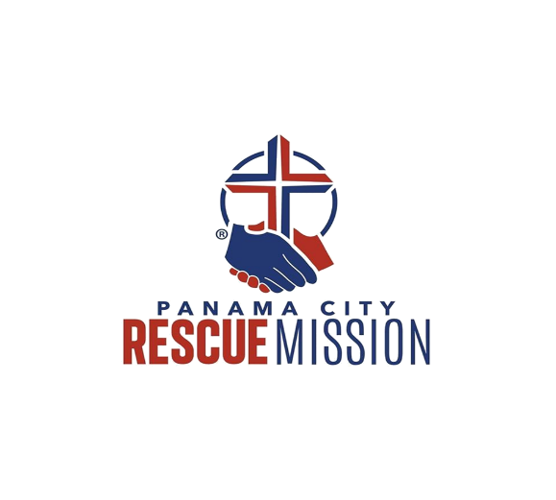
PANAMA CITY RESCUE MISSION
CURRENT NEEDS LIST

Please drop off items at our Women’s Facility located at 1313 E 11th St, Panama City, FL 32401

Deodorant Toothpaste
Shampoo Backpacks
Conditioner Suitcases
Soap Bottled Water
Toilet Paper Soda
Paper Towels Tampons
Bags Menstrual Pads
Coffee Diapers (all sizes)
Creamer Pull Ups (all sizes)
Clorox Bleach Trolley Passes
Comet Cleaner Women’s Jackets
Toilet Bowl Cleaner Advil
Floor Cleaner Tylenol
Dishwashing Liquid Azo
Paper Plates Pepto Bismol
Paper Cups Cough Medicine
Tinfoil Shower Caps
Tinfoil Pans Snack Food
Canned Goods Couch Throws
Cooking Oil Makeup
Tennis Shoes Salt
Sugar Pepper
To-Go Plates Toothbrushes
Black Pants
Blue Shirts (The type you wear to work at WalMart)
Khaki Pants
Black Tennis Shoes
New Hair Brushes

